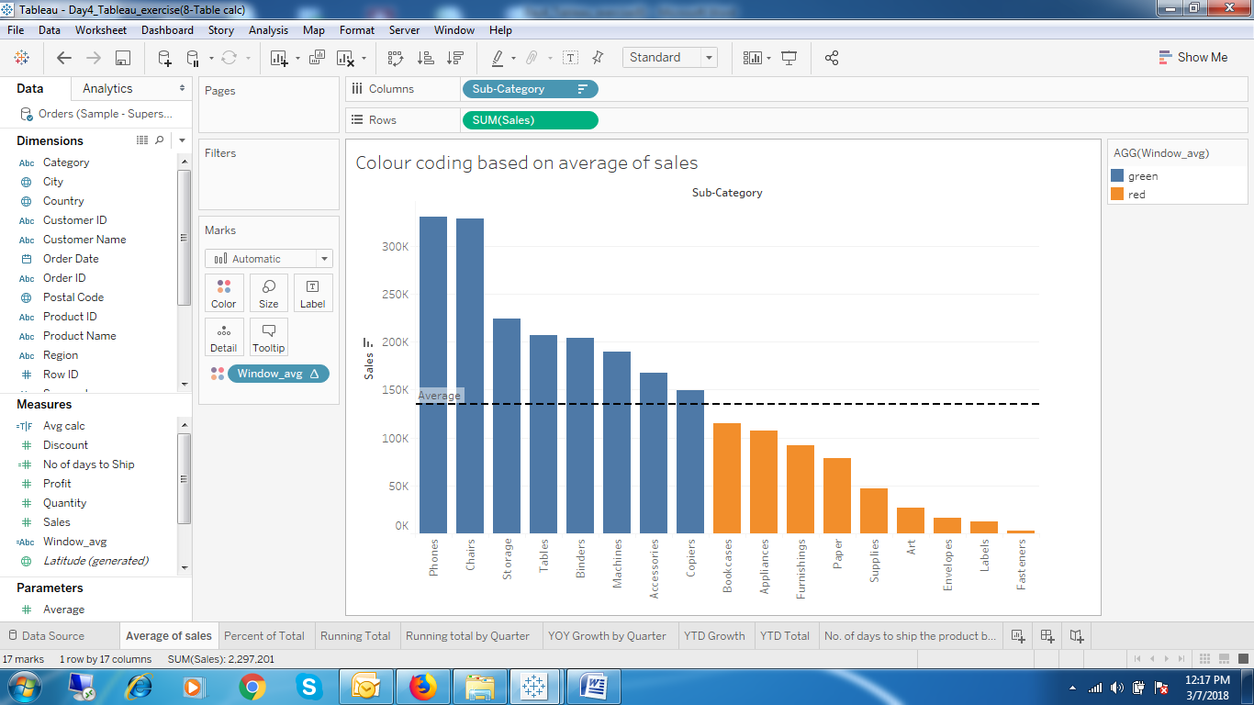

1. Colour coding based on the reference line.

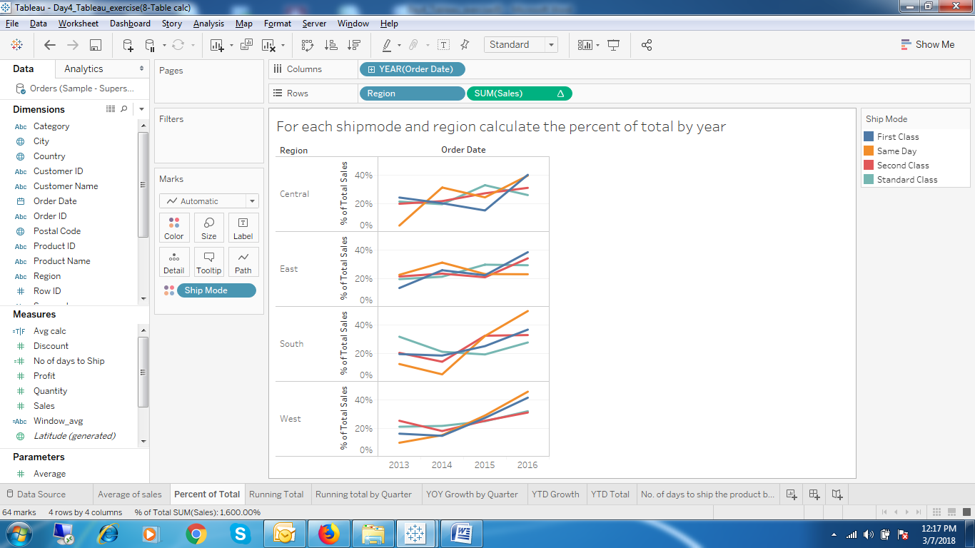

1. For each shipmode and region calculate the percent of total by year

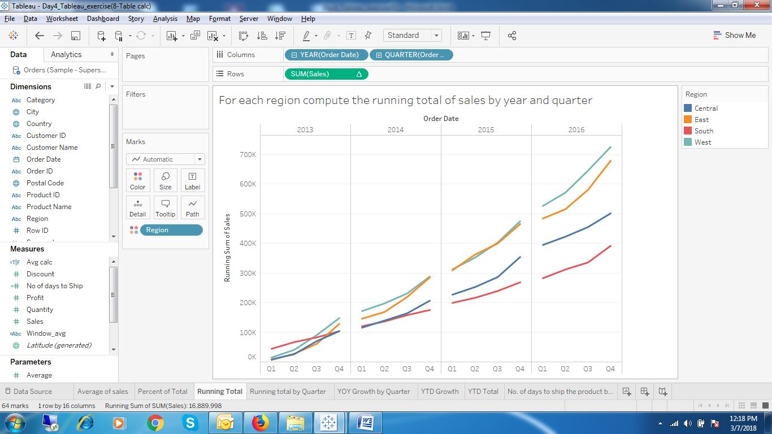

1. For each region compute the running total of sales by year and quarter

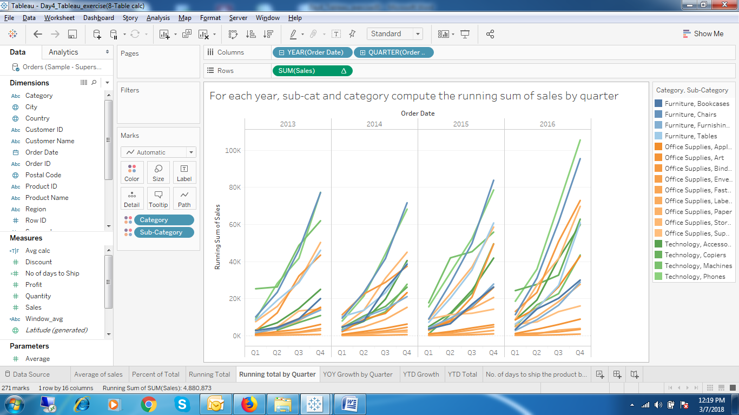

1. For each year, sub-cat and category compute the running sum of sales by quarter.

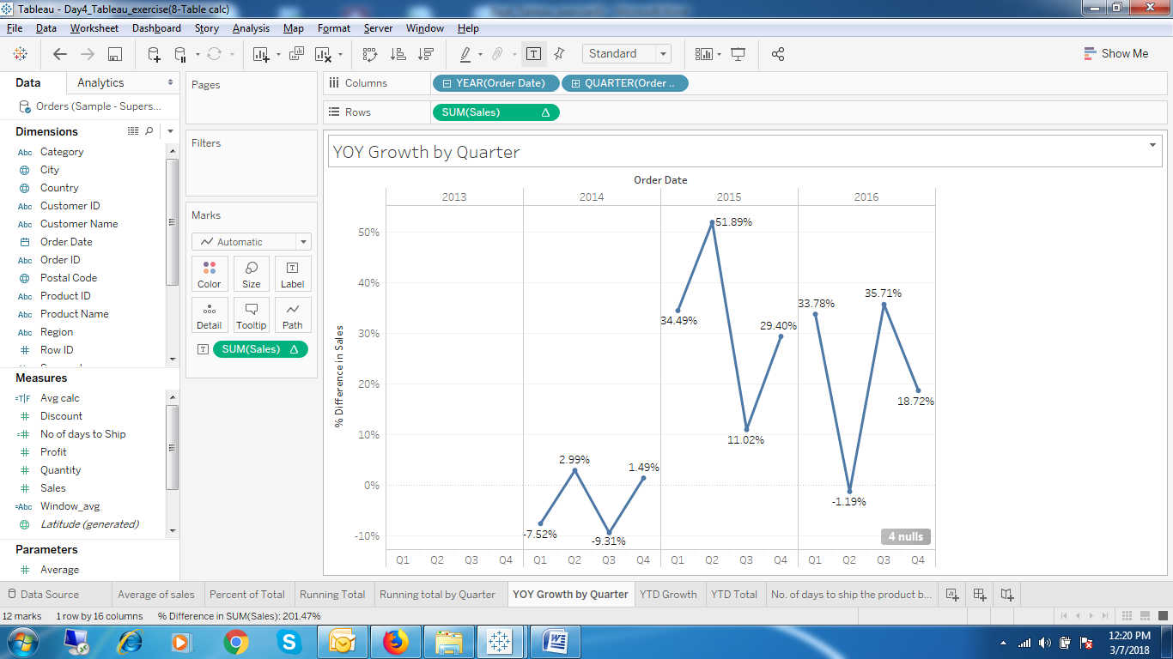

1. Year over Year Growth by Quarter

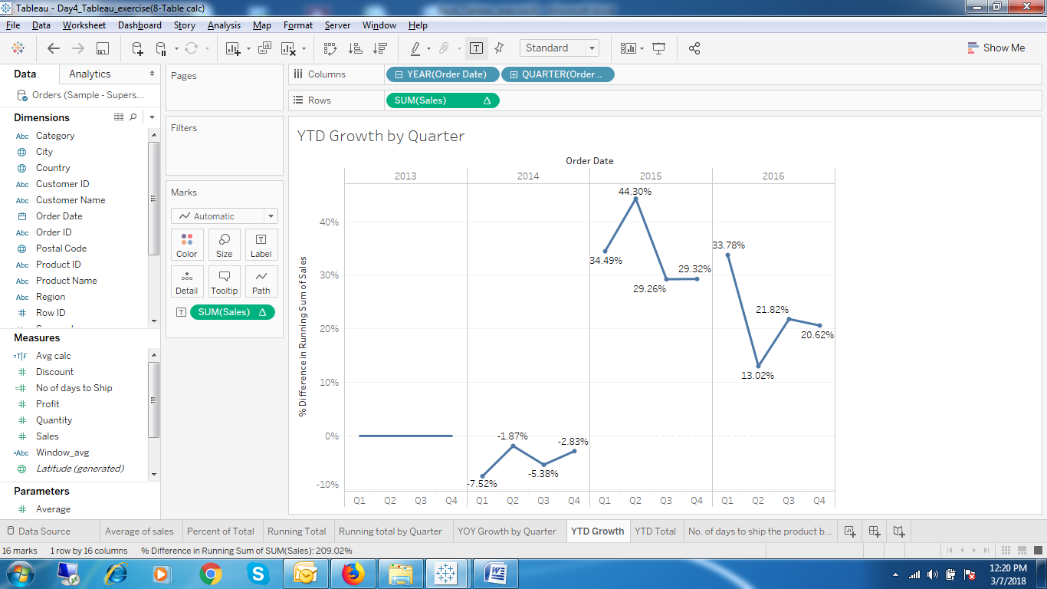

1. YTD Growth by Quarter.

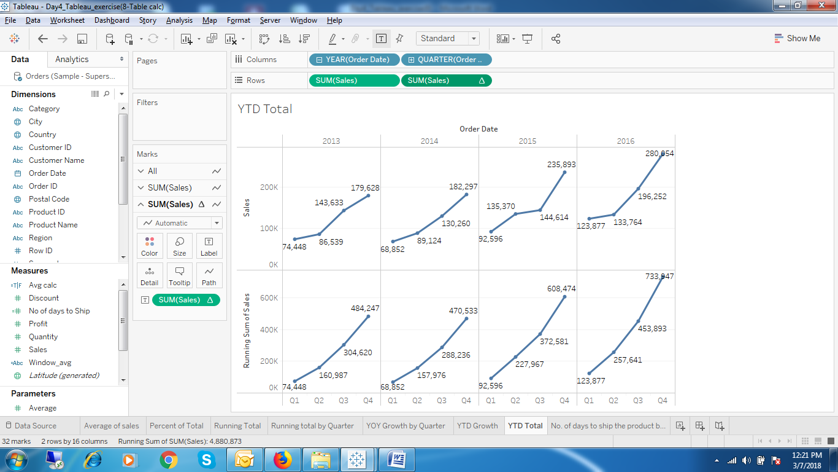

1. YTD Total by Quarter.

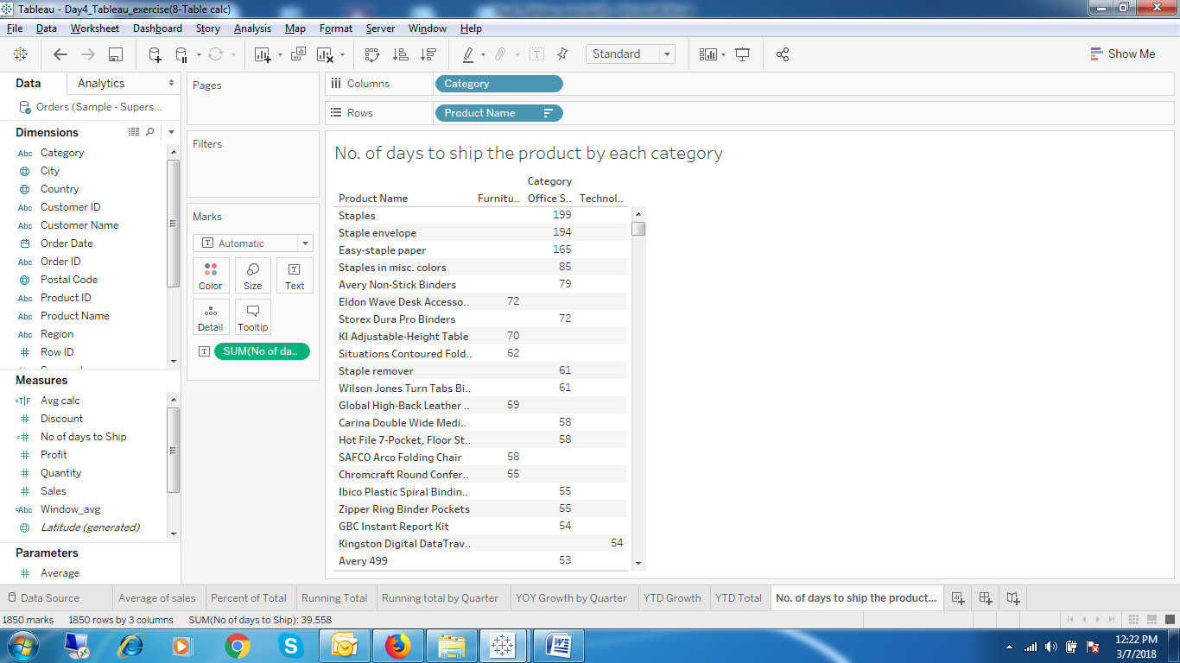

1. Number of days to ship the product by Category.